**Network Models – Assignment (Properties)**

Problem Rewritten by Jill Nguyen

**Problem Context:**

You are a wholesaler in the real estate industry and currently have 4 properties available for sale to real estate investors. Investor 1 is willing to purchase 2 properties while other investors are willing to purchase at most 1 property. Here is a brief description of the properties:

* Property 1 is an older 3 bedroom 2 bathroom home sold as is without any renovation or remodeling.
* Property 2 is a basic home with the same number of bedroom and bathroom as the first one but it has a backyard with desert landscaping.
* Property 3 is a remodeled home with 3 bedrooms and 2 bathrooms with a large backyard with grass and citrus trees and an outdoor grilling area.
* Property 4 is a larger remodeled home with 4 bedrooms 3 bathrooms and a backyard like property 3 plus a heated outdoor swimming pool.

All 4 properties are great investment opportunities for the investors and they are willing to put an offer in for the property of interest as shown below:

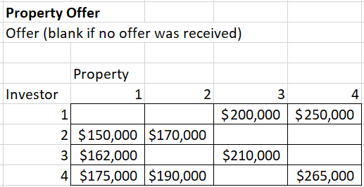

**Discussion:**

This is an example of an assignment problem where the properties are sold to the investors. The objective is to maximize the revenue of the sales for yourself the real estate wholesaler. The properties must be sold considering factors like once it is under contract with an investor, it cannot be under contract with another investor. Investor 1 is willing to purchase 2 properties whereas the other investors are willing to buy a maximum of 1 property each.